Lab Ⅱ: HDFS Hands-on Exercises

1120201548 蒋明杰

**1. Experimental environment**

OS: Ubuntu 22.04

JDK: 1.8.0_212

Hadoop version: 3.1.3

IDE: IntelliJ IDEA Community Edition 2023.1.1

1. **Experiment steps**

**2.1 Use HDFS commands for the following tasks**

1. Start HDFS

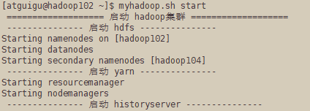

1. Out put the file

Create a new dir in HDFS





put file to the new directory in HDFS from local

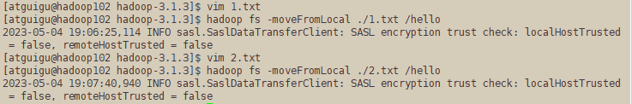

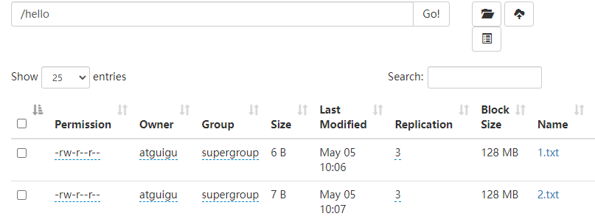

Output the information of all files in the new directionary



1. Display the content of a file in HDFS



1. Copy a text file from local file system to HDFS, if the file already exists in HDFS, append the content to the end of existing file.



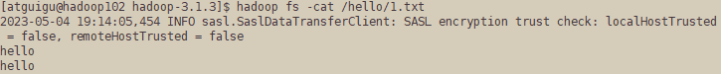





1. Copy a file from HDFS to local file system





1. Delete a file in HDFS



**2.2 Write a Java program using Hadoop Java API**

1. Copy a text file from local file system to HDFS; if the file already exists in HDFS, let the user specify whether to append the content to the end of existing file, or overwrite the original file

create hadoop environment in Windows:

System variable configuration:

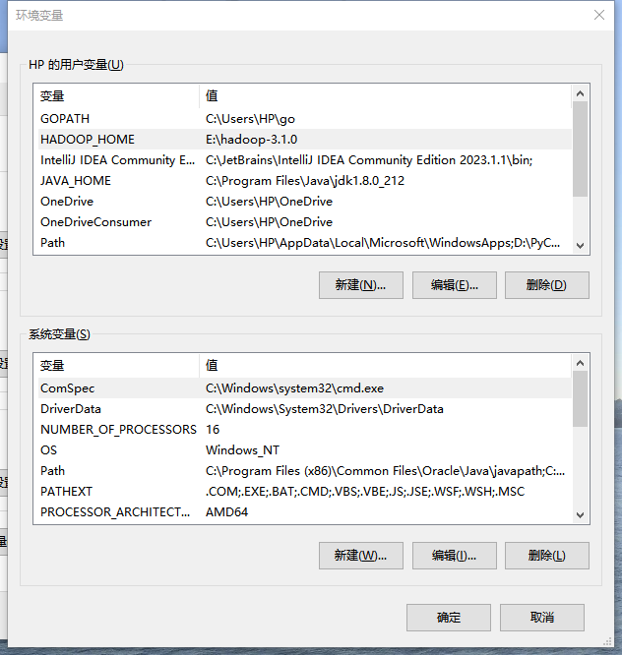

Add the dependencies:

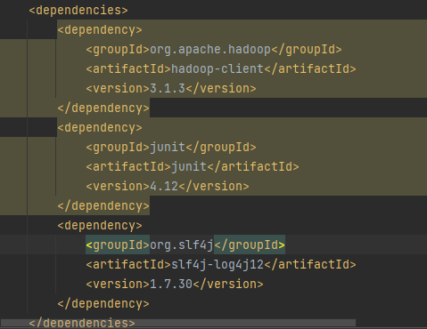

Add log4j.properties:

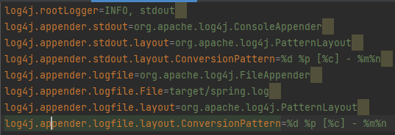

Create folder:

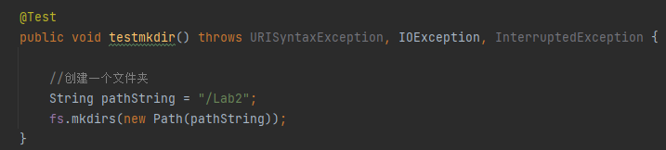



Prog1 Copy a text file from local file system to HDFS; if the file already exists in HDFS, let the user specify whether to append the content to the end of the existing file, or overwrite the original file.

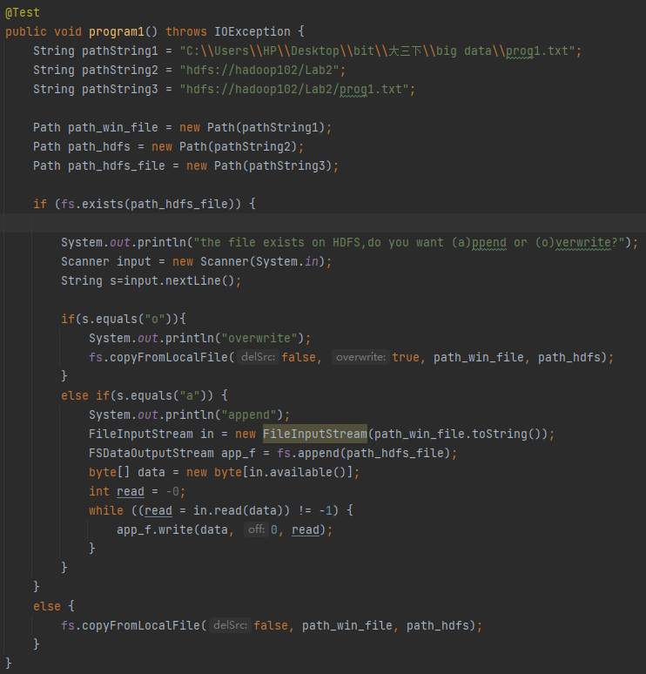

First test( file not exists):

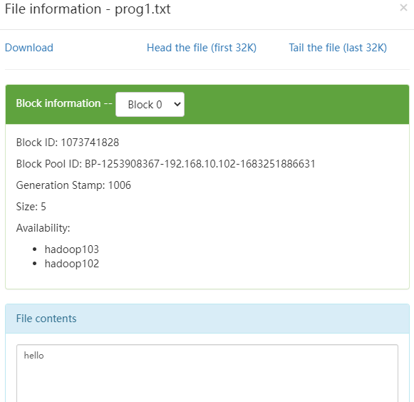

Second test(file exists) append:

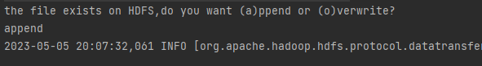

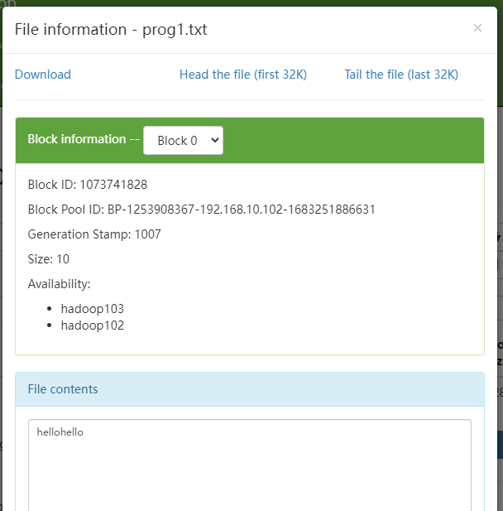

Third test(file exists) overwrite:

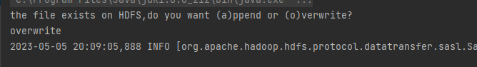

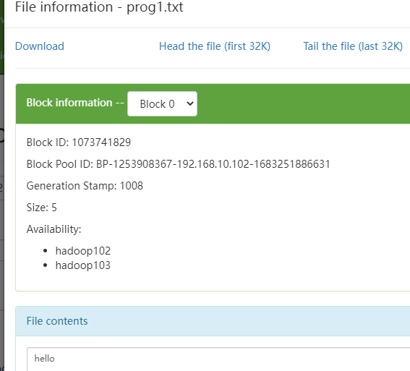

Prog2 Copy a file from HDFS to local file system; if there is a file with the same name in local file system, then rename it (the new file) automatically

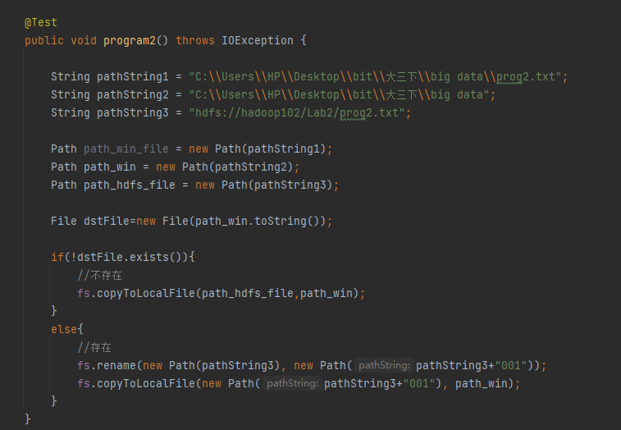

Result:



1. **Problems**
2. **When I first use the IDEJ, there are many problems on Maven**

Solution: I download a package and change maven path

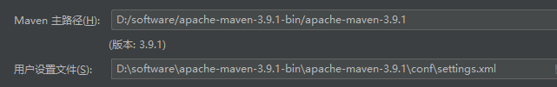

1. **Problems about using JAVA**

Solution: I’m new to JAVA, thus I need learn JAVA language before I start the lab

1. **The terminal of Junit is read-only, when I should make choice I can’t input**

Solution: Add a custom vm option:

-Deditable.java.test.console=true

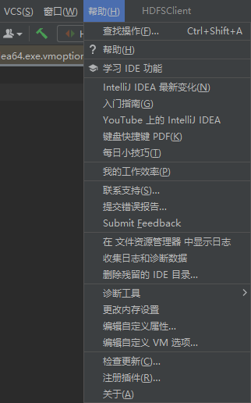



After adding, restart IDEA, then problem solved.